Returning to Smarties. What to expect!

Due to the Covid rules to keep us all safe we have changed the way some things work at Smarties. However, we have not taken away the fun and friendship and really look forward to welcoming you back to Smarties or meeting you for the first time

You will need to book the adult in (you do not need to book the child in separately). This can be done using the link on the church website or the Smarties facebook page. The session will be limited to 15 adults in addition to the volunteers.

Please do not come to Smarties if you or anyone in you household is unwell or has been asked to self- isolate.

Smarties will run from 10.15-1130. However, this may change if we decide to run two sessions.

Please wrap yourself and your children up warm as you may need to queue out side and the windows will be open in room 2 and 4 to aid ventilation.

Adults will be expected to wear a mask (unless exempt), at all times, unless sat down and socially distanced in room 4. Ideally only removed for refreshments.

When you arrive at the church you will need to wait outside on the distance markers until a member of the team invites you in and registers you using an IPAD.
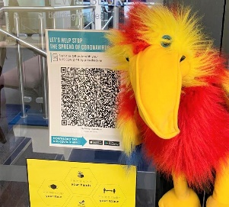
We will ask you to scan in using the QR code for the track and trace app.

We will ask you to clean your hands using alcohol hand gel.
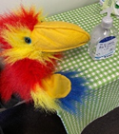
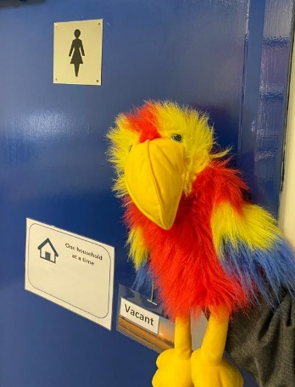
Each toilet is open for one household at a time.

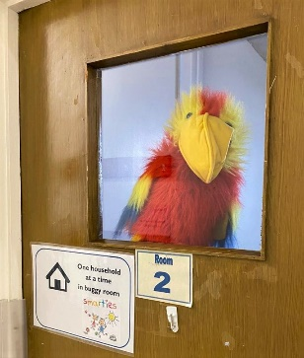
If you have a buggy with you, (please only bring one if necessary) then you will be able to park your buggy in room 1or2. 1 household at a time in each room. Please do not leave things you will need for the session or any valuables in the buggy room.
There will be a one-way system in place from the front door to room 4. If you need to go to the toilet or collect something from the buggy room you will need to exit room 4 through the fire exit and around the outside of the building, if there are other people in the corridor.

Please hang your coats on the hooks in the corridor
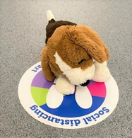
Please wait on the socially distanced spot markers to enter room 4.

The stairgate will be on the entrance to room 4. Please operate this yourself for your household. However, please ensure no toddler leaves room 4 while the stairgate is open.

On entry to room 4 please gel your hands.

Once in room 4 please select a chair to make your base and put your things on there. We are trying to avoid bags being put on the table in room 4. Your child is now free to play. The children are not expected to socially distance, but the adults are. Please keep your mask on unless you are sat down,
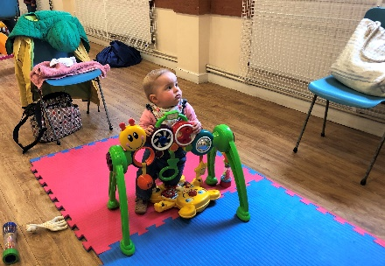
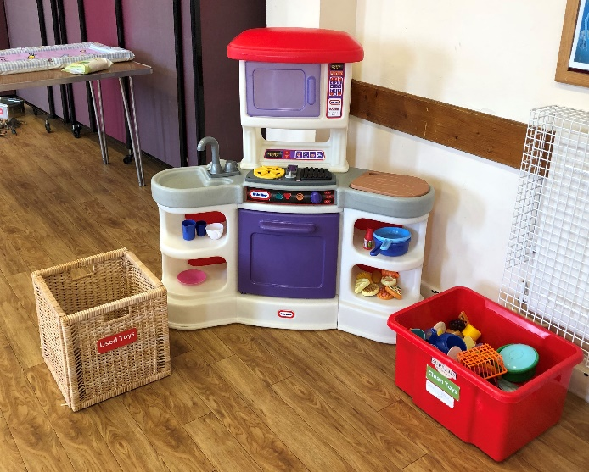
We recognize that children will share the toys. However after you child has played with some toys please put the toys in the used toy box or clean them with the wipes provided and return them to the toy zone.

Sadly, there will be no playdough this term, however colouring will be available. Each child will be given their own pot of crayons and again after your child has finished, please put the crayons in the used area or clean them.

Those with non-mobile children may wish to bring in their car seat, a baby chair or a blanket for them to be on during the session. The toys have all be cleaned, but feel free to bring your own washable toys. Again,there will be a used toy basket and wipes available for cleaning.

Refreshments will be served from the hatch with a screen. Please queue on the spot markers, no more than 3 at a time. Please bring a drink for your child. We are able to serve hot drinks, but only in disposable cups. Unfortunately, we cannot serve fruit snacks, so please do bring our own. Boxes of raisins and little packets of biscuits will be available. Please dispose of your used cup in the recycling container by the bin in room 4.

During the session adults will be able to sit with each other but chairs will be set out in a socially distanced manner. If you leave your chair and do not intend to return, please clean it with the wipes provided.

Please keep cleaning yours and your child’s hands and remember to wear your mask and socially distance at 2metres where possible. You will need to supervise your own children.
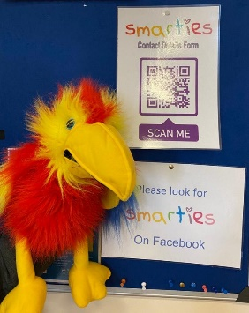

During the session please register your family details using the Google form. There will be a QR code provided to do this. We need to have your details so that we have an emergency contact number and in case we need to make last minute changes as local and national guidelines change.

If there is a spill or accident we ask that you deal with this for your own household, although our lovely volunteers will be on hand to help and keep people safe.

Singing. The leader and the children are allowed to sing but other adults cannot sing at present, however, you are allowed to join in the rhymes. If your child wants to remain with you during singing time please bring your seat closer to the singing area, but be mindful of remaining socially distanced from other adults. If your children would like to join the leader they can sit on a carpet square in front of the leader. Singing time will last for 15 minutes. It will now happen at the end of the session. Please do not talk during this time to help the singing and rhyming fun. At times we may have a story after singing, during which time some parents/ carers may be able to help with cleaning and clearing up the toys.

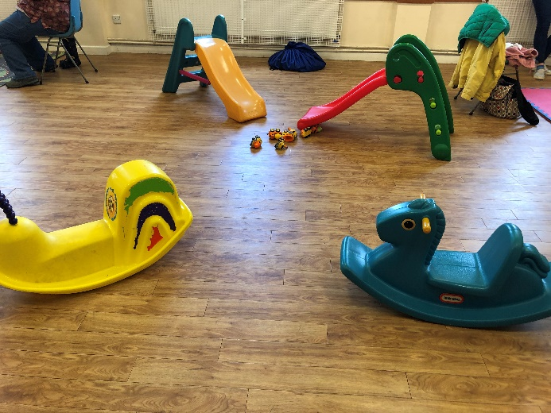
When it is time to leave Smarties, the one-way system will be reversed, you will be signed out by a volunteer and able to go and collect your coats and buggies. Please gel your households’ hands on exit and remain socially distanced as households wherever possible. Parents and children need to exit via the back door of room 4 on 6th May due to local elections happening in the church on that day.

If there is a fire alarm please exit room 4 with your children and congregate in the carpark, where the leader will check that everyone is out of the building. You are responsible for your own household. DO NOT LEAVE THE CARPARK WITHOUT TELLING THE FIRE MARSHALL IN THE FLOURESCENT TABBARD Once again our volunteers will be available to assist.

If you or your child become unwell or start exhibiting Covid symptoms within 48 hours of attending Smarties please email smarties@trinitytewkesbury.org.uk and contact the church office. Telephone no.01684293233 email office@trinitytewkesbury.org.uk and get a COVID test. If you or your child begins to feel unwell during the session please notify the leader and leave the session by the back door of room 4. A volunteer will collect your things for you. Please get a covid test and notify the church by the above means when you have the result.

If you have any further comments, querries or questions on the new arrangements for Smarties please do not hesitate to ask using the above contact details or the Smarties facebook page or group. We so look forward to seeing you all back at Smarties.

